Interested in insect allergy?

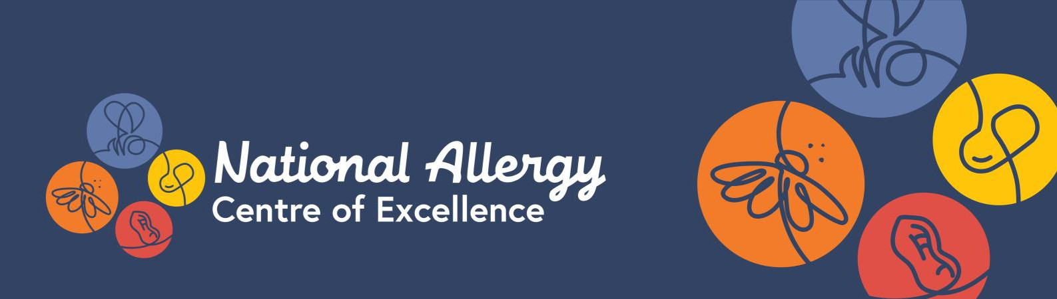
Learn from leading experts
The National Allergy Centre of Excellence (NACE) is offering a PhD Scholarship focusing on insect allergy research.

Australia is home to some of the world’s deadliest creatures – insect bite and sting allergy is one of the leading causes of fatal anaphylaxis in the country. To help accelerate our research, the NACE is calling on the next generation of allergy experts to apply for a PhD opportunity that will focus on prevention, management or treatment of insect allergy.

Eligibility

- Graduates with minimum Honours degree - or equivalent - in the fields of molecular, biological and medical sciences, population health and statistics, data linkage, health economics and healthcare policy OR
- Healthcare professionals, including - but not limited to - allergy/immunology or respiratory trainees/fellows, general paediatricians, dietitians, pharmacists, nurses and other allied
health professionals
- Successful completion of Honours or Masters by PhD start date
- First year PhD candidates (currently unfunded)
- Exceptional Masters candidates with an interest in insect allergy will also be considered
- You are driven to be part of Australia’s next generation of allergy researchers
- You and your primary supervisor must be NACE members – join here
- One member of your supervisory panel must be a member of the NACE Insect Allergy Stream Advisory Group
- You must be an Australian resident
The Scholarship will be awarded contingent on enrolment in a PhD course at a recognised Australian institution. The Scholarship will provide PhD stipend only, equivalent to NHMRC stipend rates.
Research focus
Your PhD topic will focus on allergy prevention, management or treatment, in the NACE Insect Allergy Stream. It will include a systematic review on a topic aligned with aims of the NACE.
How to apply
1 February 2023

- Expressions of Interest for an
insect allergy PhD open
5pm, 28 February 2023

- EOIs close. Email your EOI form,
- Successful EOI applicants will be advised of the next step in the application process
April - May 2023
- Awardee announced
Semester 2 2023
- PhD Scholar commences
CV and academic transcript to: nace@mcri.edu.au
March 2023

Expression of Interest
NACE Postgraduate Research Scholarship - Insect Allergy
Thank you for taking part in the EOI process. Please complete this form and email it to nace@mcri.edu.au along with your CV and academic record by 5pm, 28 February 2023.

Applicant details

Name:

Email:

Address:

Are you an Australian resident?

YES

NO

Are you a NACE member (join here)?

YES

NO

Academic qualifications (please submit your CV and academic record with this form)

Degree | University | Department | Date awarded/expected

Research experience (list two most recent)

Role | Organisation & dept. | Start date | End date

Proposed research degree

Proposed institution (if known):

Proposed study (please select one):

Full-time

Part-time

Please outline your medium and longer term aspirations regarding your role in insect allergy prevention, management and/or treatment in Australia, as well as what drives your passion for a career in allergy research (250 words):

Eligibility and selection process

Candidates for the fellowships are required to have a primary supervisor who is a NACE member and a person on your supervisory panel (i.e. co-supervisor, associate supervisor) who is a member of a NACE Insect Allergy Stream Advisory Group. Your proposed topic must be within the scope and theme of the Stream. Successful EOI applicants will be advised of the next steps in the application process in March 2023. Applications will be assessed on criteria of academic record and achievement relative to opportunity, research environment and the research project’s alignment with the NACE mission.

To learn more, please visit the National Allergy Centre of Excellence and follow @NACEresearch on Twitter or linkedin.com/company/naceresearch for regular updates.

